Kadijatu Bah

09/14/2018

Wireshark lab 2

1. Is your browser running HTTP version 1.0 or 1.1?

* **My browser uses HTTP version 1.1.**



1. When was the HTML file that you are retrieving last modified at the server?

* **Since I got an error response I don’t see the last-modified date section, but I got a date response that says Friday, 14 Sept. 2018.**

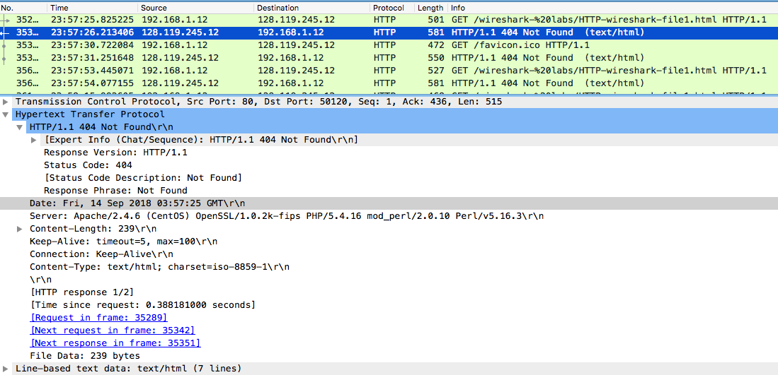

1. What is the IP address of your computer? Of the gaia.cs.umass.edu server?

* **The IP address of my machine is 192.168.1.12**
* **The IP address of the website is 128.119.245.12**



1. What languages (if any) does your browser indicate that it can accept to the

server?

* **The language used is US-English.**

1. When was the HTML file that you are retrieving last modified at the server?

* **Since I got an error response I don’t see the last-modified date section, but I got a date response that says Friday, 14 Sept. 2018.**

